AGGREGATION OPERATORS
Aggregation in MongoDB is a powerful feature that allows for complex data transformations and computations on collections of documents. It enables users to group, filter, and manipulate data to produce summarized results.
What is aggregation?
- MongoDB Aggregation is a database process that allows us to perform complex data transformations and computations on collections of documents or rows.
- It enables us to group, filter, and manipulate data to produce summarized results. MongoDB Aggregation is typically carried out using the aggregation pipeline, which is a framework for data aggregation modeled on the concept of data processing pipelines. As they pass through it and allowing for operations like filtering, grouping, sorting, reshaping and performing calculations on the data.
AGGREGATE OPERATORS :
- Execute Aggregation operations ($avg, $min,$max, $push, $addToSet etc.). students encourage to execute several queries to demonstrate various aggregation operators)
Introduction :
- Aggregation means grouping together
- For example sum, avg, min, max
Syntax : db.collection.aggregate(<AGGREGATE OPERATION>
TYPES

Expression Type | Description | Syntax
Accumulators | Perform calculations on entire groups of documents
* $sum | Calculates the sum of all values in a numeric field within a group. | "$fieldName": { $sum:  "$fieldName" }
* $avg | Calculates the average of all values in a numeric field within a group. | "$fieldName": { $avg:  "$fieldName" }
* $min | Finds the minimum value in a field within a group. | "$fieldName": { $min:  "$fieldName" }
* $max | Finds the maximum value in a field within a group. | "$fieldName": { $max:  "$fieldName" }
* $push | Creates an array containing all unique or duplicate values from a field | "$arrayName": { $push:  "$fieldName" }
* $addToSet | Creates an array containing only unique values from a field within a group. | "$arrayName": { $addToSet:  "$fieldName" }
* $first | Returns the first value in a field within a group (or entire collection). | "$fieldName": {  $first:  "$fieldName" }
* $last | Returns the last value in a field within a group (or entire collection). | "$fieldName": { $last:  "$fieldName" }

EXAMPLE : Average GPA of All Students
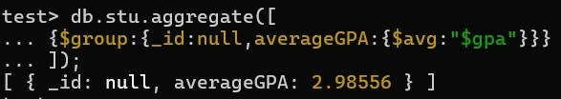
Explanation:
$group: Groups all documents together.
_id: null: Sets the group identifier to null (optional, as there's only one group in this case).
averageGPA: Calculates the average value of the "gpa" field using the $avg operator.
EXAMPLE 2: Minimum and Maximum Age

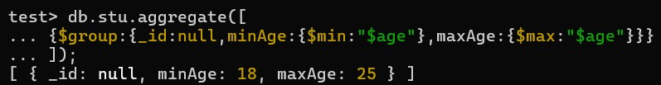

Explanation:
- Similar to the previous example, it uses $group to group all documents.
- minAge: Uses the $min operator to find the minimum value in the "age" field.
- maxAge: Uses the $max operator to find the maximum value in the "age" field.

